1.a

touch 21301380_1.txt 21301380_2.txt 21301380_3.txt 21301380_4.txt

mkdir Zarin01 Zarin02

mv 21301380_1.txt 21301380_2.txt 21301380_3.txt Zarin01/

cp Zarin01/21301380_1.txt Zarin02/

cp Zarin01/21301380_2.txt Zarin02/

mkdir Zarin03

cp -e Zarin01 Zarin03/

cp -r Zarin01 Zarin03/

cd Zarin03

ls -R

cd Zarin01/

chmod go=rx 21301380_1.txt 21301380_2.txt 21301380_3.txt

cd ..

chmod go=rx Zarin01

cd ..

mv Zarin03 /

sudo mv Zarin03 /

rm -r Zarin01 Zarin02 21301380_4.txt

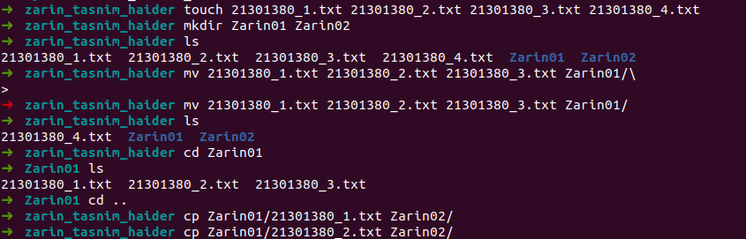

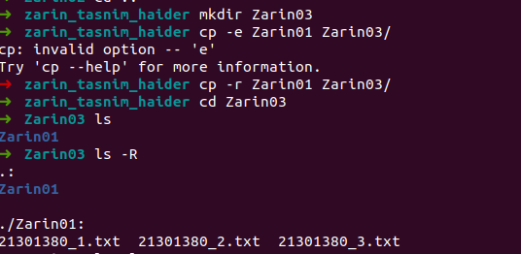

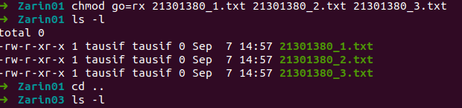

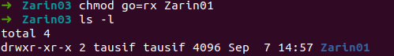

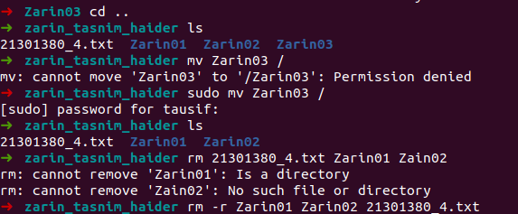

b)

cat > course.txt

CSE321 Operating System Section 11

CSE428 Image Processing Section 02

CSE470 Software Engineering Section 09

CSE360 Computer Interfacing Section 05

cat course.txt

grep -c "CSE" course.txt

c)

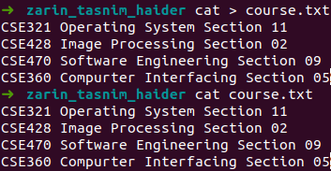



c) stat *

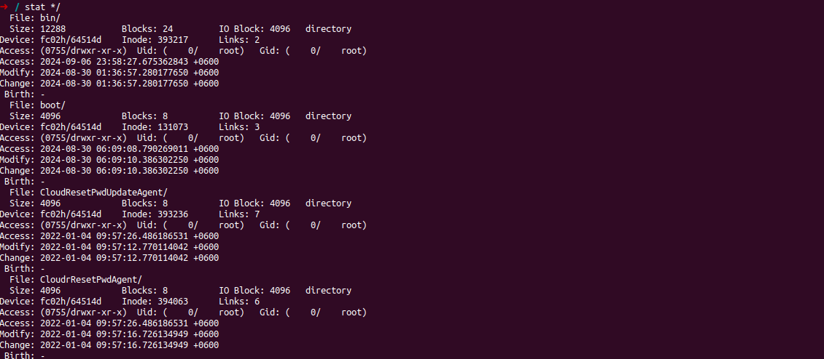

d) cat >temp.txt

head -n 17 temp.txt | tail -n 13

